**Test Case 3**

**System:** Bench

**Description:** Test that the user could send a message request successfully.

**Severity:** 5

**Instructions**

**Test 1**

1. Start the Bench application.
2. Click the button “Login” on the navigation bar.
3. Enter the email “team23project@gmail.com” into the text field labeled “Email address”.
4. Enter the password “12345678” into the field labeled “Password”.
5. Click the button “Login” below the field.
6. After the screen has loaded, click on the button “View Profile” on any of the user panels shown because they are all matched with the current user.
   1. “User3” is selected in this example.
7. In the selected user’s profile page, click the button “Send Chat Request”.

**Expected Result:** If the chat room between the current user and the selected user hasn’t been created previously, then there would be an alert saying that a request is successfully sent. (Otherwise, there would be an alert saying that you already have access to chatting with this selected user.)

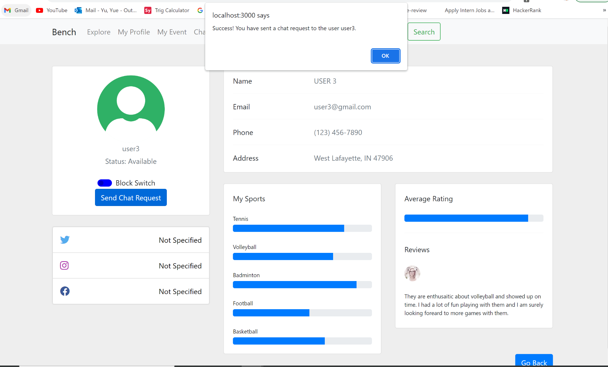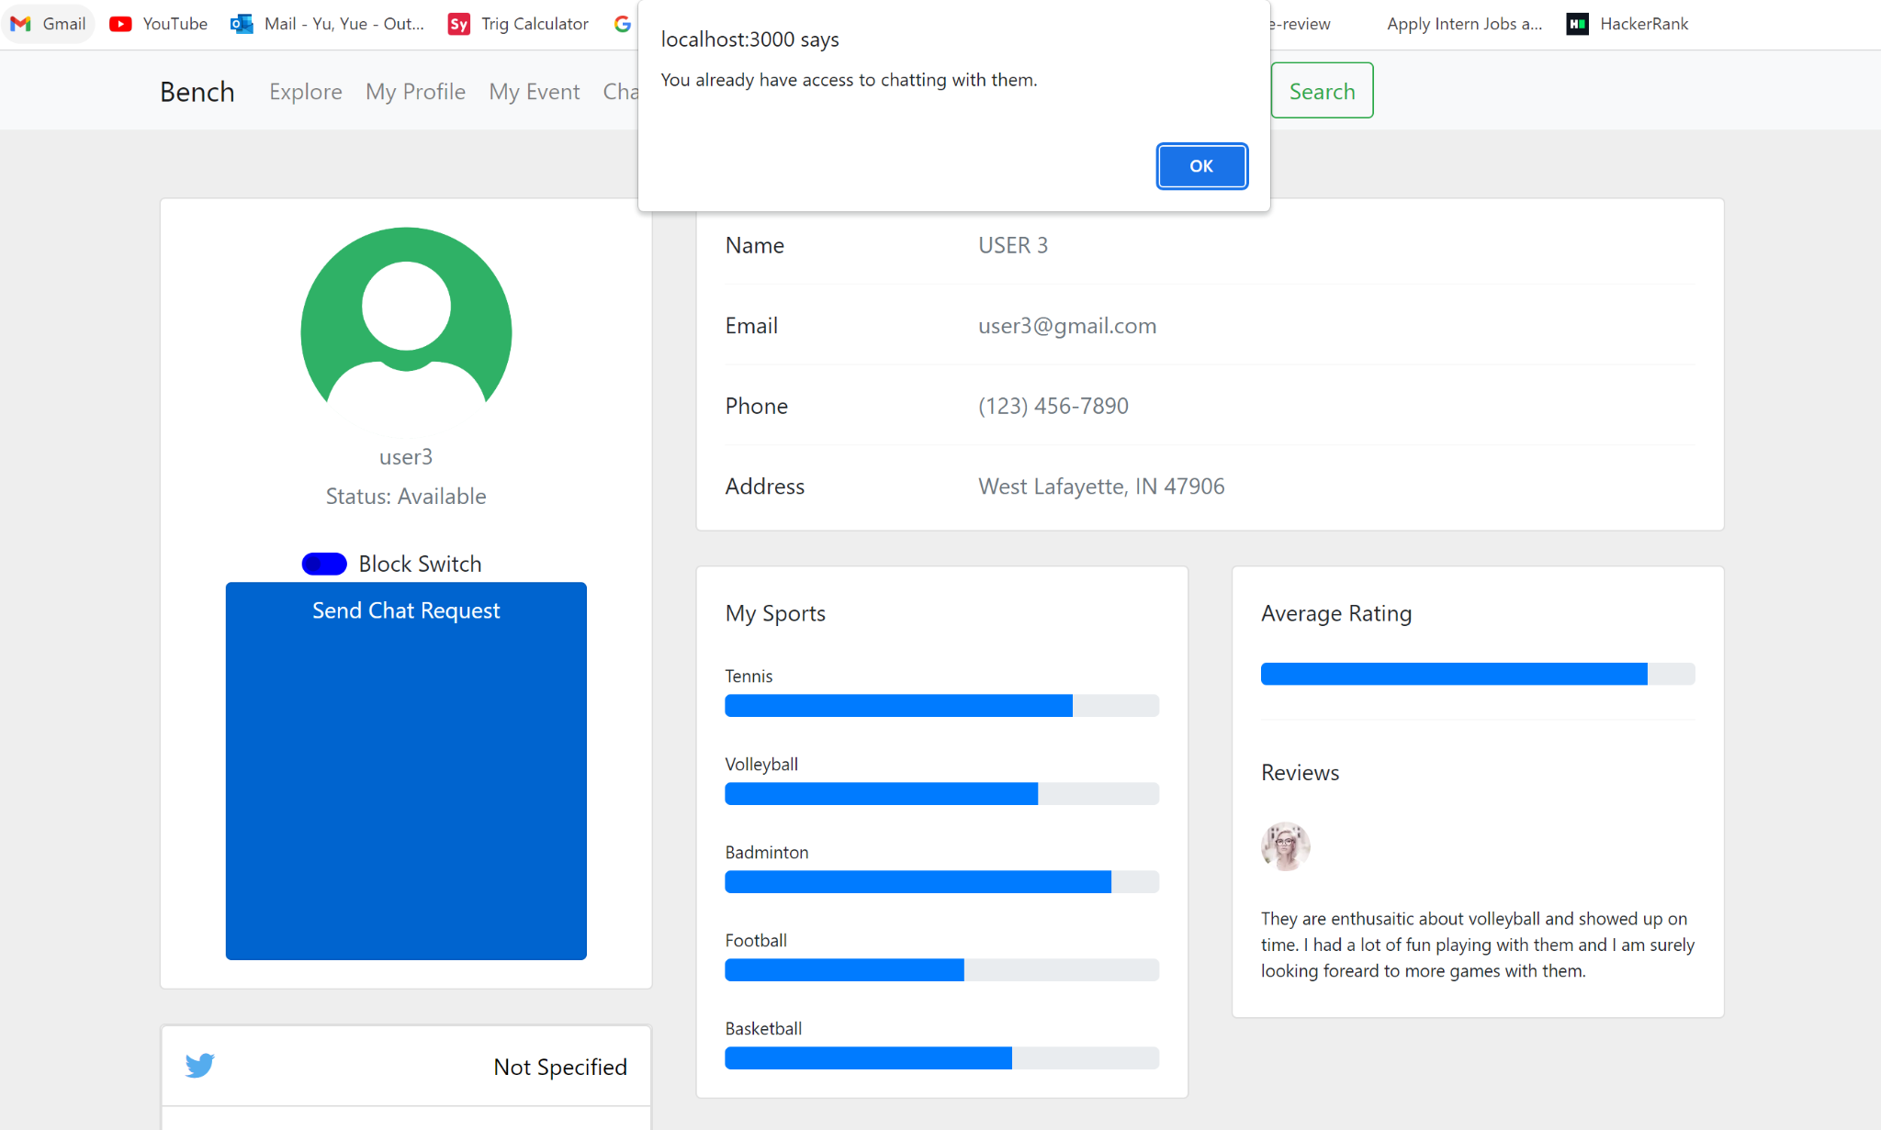

**Test 2**

1. Start the Bench application.
2. Click the button “Login” on the navigation bar.
3. Enter the email “team23project@gmail.com” into the text field labeled “Email address”.
4. Enter the password “12345678” into the field labeled “Password”.
5. Click the button “Login” below the field.
6. After the screen has loaded, click on the button “View Profile” on any of the user panels shown because they are all matched with the current user.
   1. “User3” is selected in this example.
7. In the selected user’s profile page, click the button “Send Chat Request”.
8. If the chat room between the current user and the selected user hasn’t been created previously, then there would be an alert saying that a request is successfully sent. This is the condition for the test steps below. (Otherwise, there would be an alert saying that you already have access to chatting with this selected user.)
9. Click the button “Logout” on the navigation bar.
10. Because the previously chat-requested user is user3, enter the email “user3@gmail.com” into the text field labeled “Email address” to login as user3.
11. Enter the password “12345678” into the field labeled “Password”.
12. Click the button “Login” below the field.
13. After the screen has loaded, click on the button “Chat” on the navigation bar.
14. There should appear a panel for the incoming chat request, labeled with the request-sender’s username, a button for accepting it, and a button for declining it.
15. Verify that the request-sender’s username is “TEAM 23” because this is the initial account that we used to send the chat request earlier.
16. Click the button labeled with a check mark to accept the chat request from the sender.
17. The panel of the chat request you just responded to should disappear.

**Expected Result:** There should appear a new panel of the new chat room created between the current user “user3” and the sender user “TEAM 23”, labeled with the other user’s username “TEAM 23” and a line of text that says you have accepted the request.

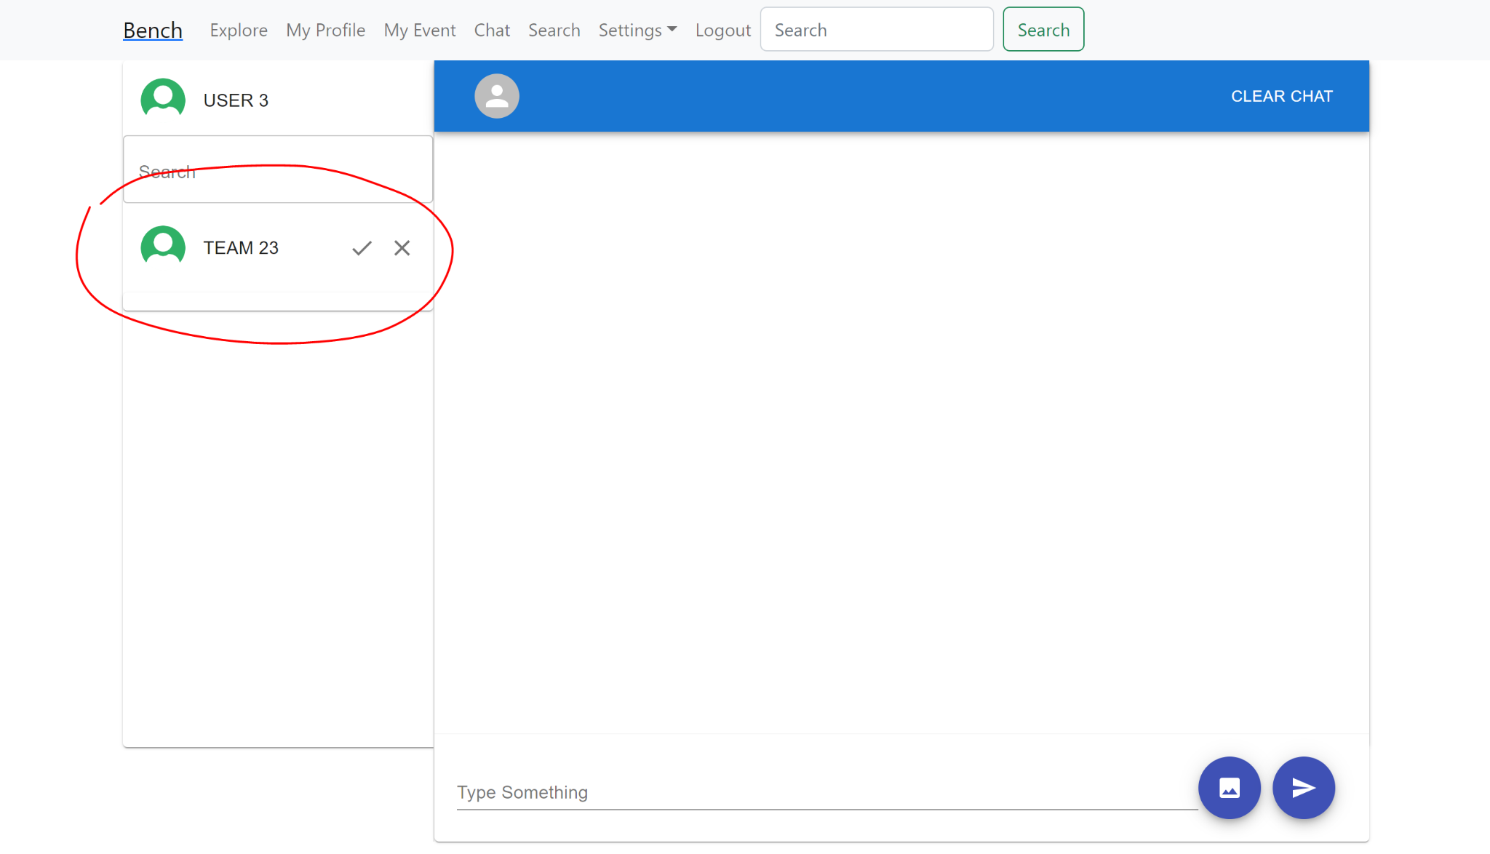

**Test 3**

1. Start the Bench application.
2. Click the button “Login” on the navigation bar.
3. Enter the email “team23project@gmail.com” into the text field labeled “Email address”.
4. Enter the password “12345678” into the field labeled “Password”.
5. Click the button “Login” below the field.
6. After the screen has loaded, click on the button “View Profile” on any of the user panels shown because they are all matched with the current user.
   1. “User3” is selected in this example.
7. In the selected user’s profile page, click the button “Send Chat Request”.
8. If the chat room between the current user and the selected user hasn’t been created previously, then there would be an alert saying that a request is successfully sent. This is the condition for the test steps below. (Otherwise, there would be an alert saying that you already have access to chatting with this selected user.)
9. Click the button “Logout” on the navigation bar.
10. Because the previously chat-requested user is user3, enter the email “user3@gmail.com” into the text field labeled “Email address” to login as user3.
11. Enter the password “12345678” into the field labeled “Password”.
12. Click the button “Login” below the field.
13. After the screen has loaded, click on the button “Chat” on the navigation bar.
14. There should appear a panel for the incoming chat request, labeled with the request-sender’s username, a button for accepting it, and a button for declining it.
15. Verify that the request-sender’s username is “TEAM 23” because this is the initial account that we used to send the chat request earlier.
16. Click the button labeled with a check mark to accept the chat request from the sender.
17. The panel of the chat request you just responded to should disappear.
18. There should appear a new panel of the new chat room created between the current user “user3” and the sender user “TEAM 23”, labeled with the other user’s username “TEAM 23” and a line of text that says you have accepted the request.
19. Click the button “Logout” on the navigation bar.
20. Because the initial account we used to send the chat request is TEAM 23, enter the email “team23@gmail.com” into the text field labeled “Email address” to login as TEAM 23.
21. Enter the password “12345678” into the field labeled “Password”.
22. Click the button “Login” below the field.
23. After the screen has loaded, click on the button “Chat” on the navigation bar.

**Expected Result:** There should appear a new panel of the new chat room created between the recipient user “user3” and the current user “TEAM 23”, labeled with the other user’s username “user3” and a line of text that says that the recipient user has accepted your request.

